UX Check Results

# Heuristic: Visibility of system status

# Severity: 0

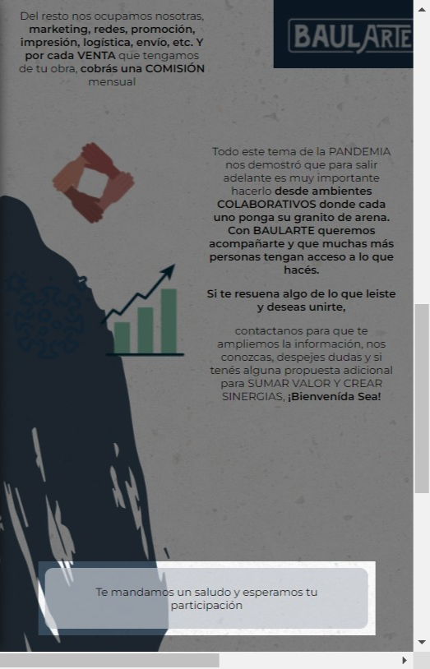

# Notes:

no va con boton

# Heuristic: Visibility of system status

# Severity: 0

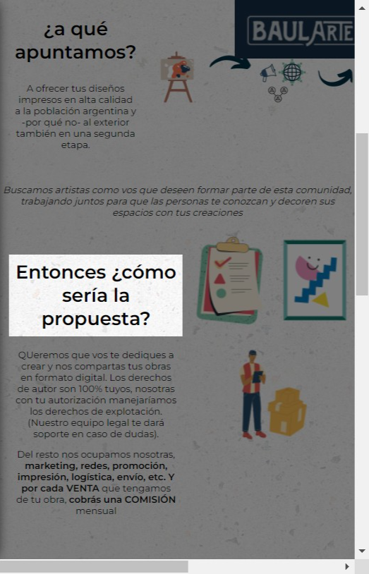

# Notes:

no es un titulo

# Recommendation:

va con un pincel y solo en negrita

# Heuristic: Visibility of system status

# Severity: 0

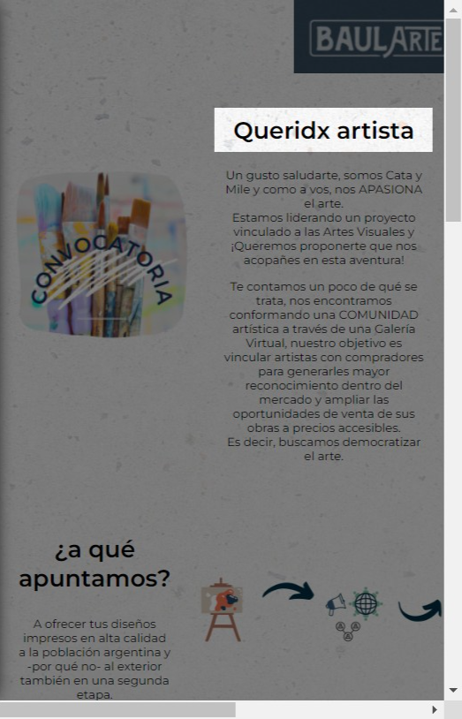

# Notes:

mayusculas

# Heuristic: Visibility of system status

# Severity: 0

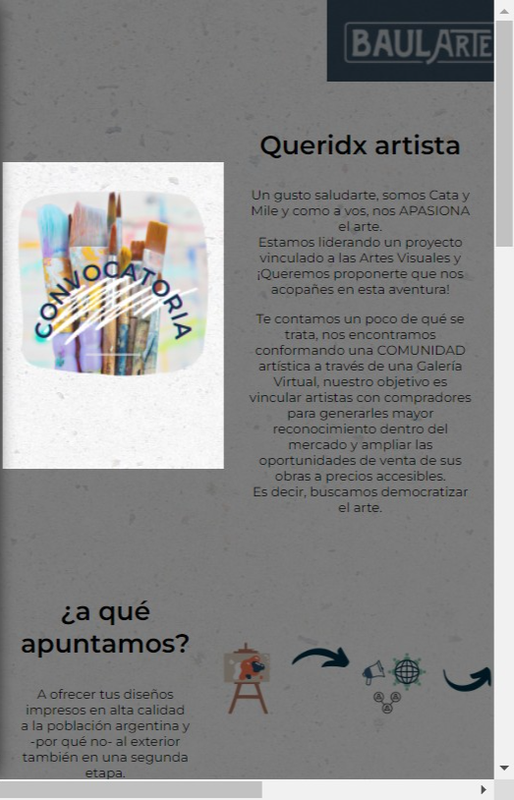

# Notes:

idem anterior, duplicar los tamaños

# Heuristic: Visibility of system status

# Severity: 0

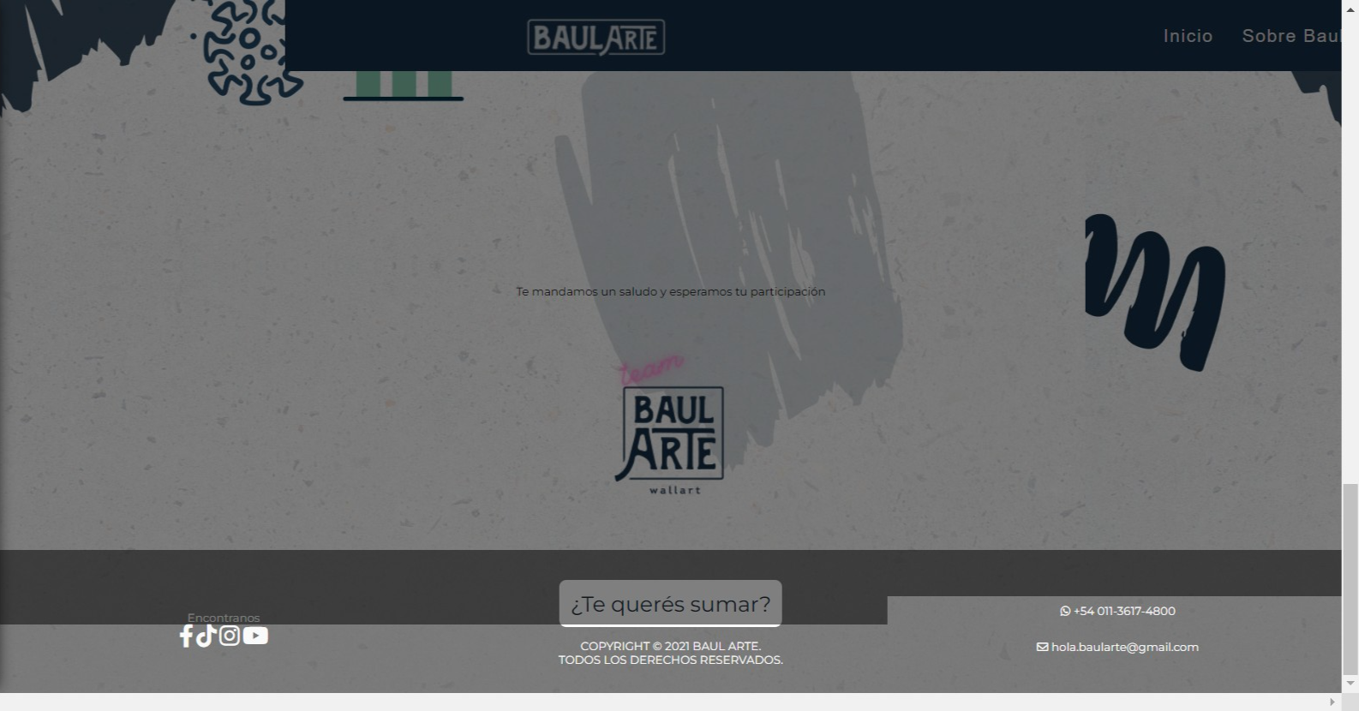

# Notes:

idem

# Heuristic: Visibility of system status

# Severity: 0

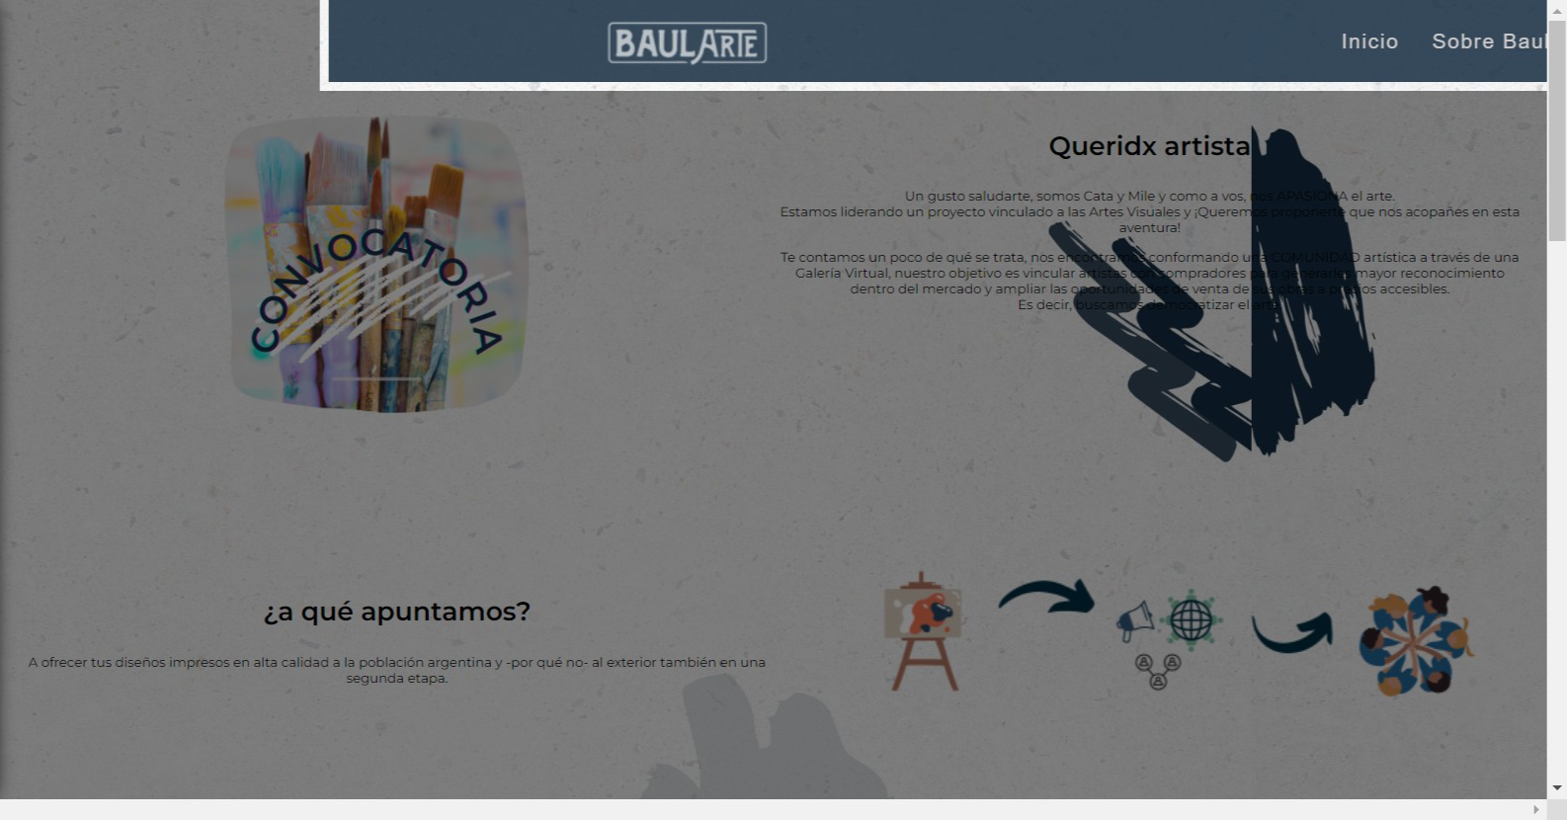

# Notes:

idem